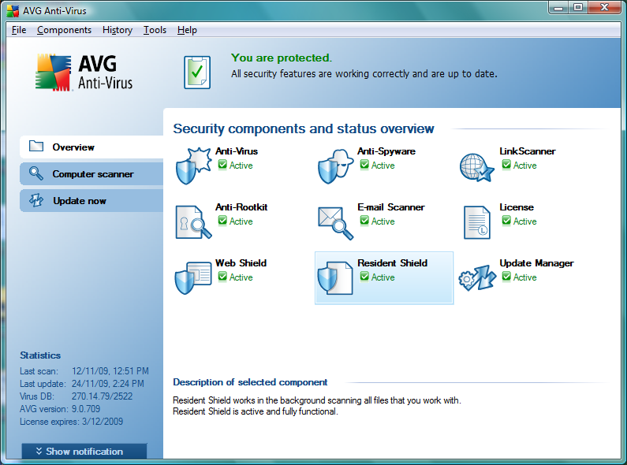
Double click on the Resident Shield and it will direct you to below page.
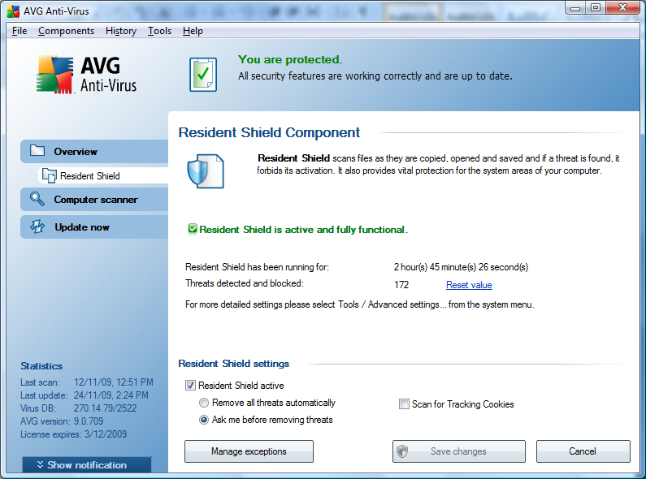
Under the Resident Shield setting, please select “Ask me before removing threats”. After done please click on the Manage exceptions button.

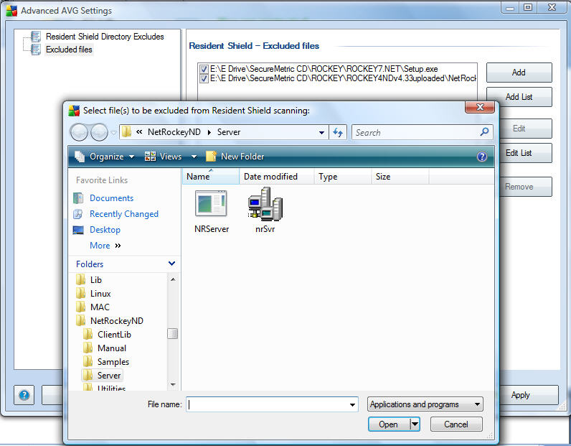
In the exceptions page, please select the Excluded files on your left hand side and you can click the Add button to add the particular file into exception list.
After selected the files, please click on Apply and OK to complete the exception step.

